Software Requirements Specification

for

Event Management System
Version 1.0 approved
Prepared by Mohammad Zaid (PES1UG24CS577), E Bhuvan (PES1UG24CS568), Praveen (PES1UG25CS832), and Mohammed Ibrahim Maqsood Khan (PES1UG24CS578), Team 7
PES University
September 9, 2026
Table of Contents
Table of Contents ii
Revision History ii
1. Introduction 1
1.1 Purpose 1
1.2 Intended Audience and Reading Suggestions 1
1.3 Product Scope 1
1.4 References 1
2. Overall Description 2
2.1 Product Perspective 2
2.2 Product Functions 2
2.3 User Classes and Characteristics 2
2.4 Operating Environment 2
2.5 Design and Implementation Constraints 2
2.6 Assumptions and Dependencies 3
3. External Interface Requirements 3
3.1 User Interfaces 3
3.2 Software Interfaces 3
3.3 Communications Interfaces 3
4. Analysis Models
5. System Features 4
5.1 Event Creation and Management 4
5.2 Attendee Registration 4
6. Other Nonfunctional Requirements 4
6.1 Performance Requirements 4
6.2 Safety Requirements 5
6.3 Security Requirements 5
6.4 Software Quality Attributes 5
6.5 Business Rules 5
7. Other Requirements 5
Appendix A: Glossary 5
Appendix B: Field Layouts 5
Appendix C: Requirement Traceability matrix 6

Revision History
Name | Date | Reason For Changes | Version
E Bhuvan | 09-Sep-2026 | Initial draft of the SRS document | 1.0
Mohammad Zaid | 09-Sep-2026 | Appendix c | 1.0
E Bhuvan | 02-Oct-2026 | Add proper UML diagram, Thighten requirements REQ-1 through REQ-4, Add Security Requirements | 1.0

Introduction

Purpose
This document specifies the software requirements for the Event Management System, version 1.0, developed by Team 7. The system is a web application that lets organizers create and manage events and lets attendees discover events and register for them online. This SRS covers the complete system, including the organizer facing management tools and the attendee facing registration flow.

Intended Audience
This document is intended for the development team building the Event Management System, the course instructor and evaluators reviewing the project, and any future contributor who needs to understand what the system is supposed to do. Section 2 gives an overall description of the product, Section 3 covers the external interfaces, Section 5 lists the system features and their functional requirements, and Section 6 covers the remaining nonfunctional requirements.

Product Scope
The Event Management System is a web based platform for organizing and running events with online registration. Organizers can create events, edit event details, and keep track of who has registered. Attendees can browse upcoming events, view event details, and register directly from the site. The goal is to replace manual, spreadsheet based event coordination with a single system that keeps event information and registrations in one place.

References
React documentation, https://react.dev. Node.js documentation, https://nodejs.org/en/docs. Django documentation, https://docs.djangoproject.com. IEEE Recommended Practice for Software Requirements Specifications, IEEE Std 830-1998.

Overall Description

Product Perspective
The Event Management System is a new, self contained web application built for this course project. It is not a follow on to an existing product. The system has a browser based frontend that organizers and attendees interact with, a backend application server that handles business logic and authentication, and a database that stores event and registration data.

Product Functions
The major functions of the system are creating, editing, and deleting events; browsing the list of upcoming events along with their details; registering for an event as an attendee; and viewing the list of attendees who have registered for a given event. Only the organizer who created an event can edit or manage it.

User Classes and Characteristics
There are two main user classes. Organizers create and manage events. They use the system whenever they are running an event and need access to the full set of event management functions. Attendees browse events and register for them. They are casual users who only need to view event details and complete a short registration form, so their side of the interface has to stay simple and quick to use.

Operating Environment
The system runs as a web application accessed through a standard modern browser such as Chrome, Firefox, or Edge, on any operating system that supports one of these browsers. The frontend is built with React.js, the backend is built with Node.js and Python Django, and the server components are expected to run on a Linux based hosting environment with access to a relational database.

Design and Implementation Constraints
The frontend has to be built using React.js, and the backend has to be built using Node.js and Python Django, since these are the technologies chosen for this project. The system has to be deliverable within the course project timeline, which limits the scope of features that can realistically be implemented. The team also has to work within the free tiers of any hosting or database services used for deployment.

2.6 Assumptions and Dependencies
It is assumed that all users have access to a reasonably modern web browser and a stable internet connection. The project depends on third party libraries and frameworks, including React, Node.js, and Django, continuing to be available and stable for the duration of development. It is also assumed that event details entered by organizers are accurate, since the system does not verify them against any external source.

External Interface Requirements

User Interfaces
The system provides a web based user interface with two main views. The organizer view includes a dashboard for creating and managing events and a page for viewing the list of attendees registered for each event. The attendee view includes a browsable list of upcoming events and a registration form for each event. Both views follow a consistent, simple layout with a navigation bar, standard buttons for actions like Create, Edit, Delete, and Register, and clear error messages whenever a form is submitted with missing or invalid information.

Software Interfaces
The frontend is built with React.js and communicates with the backend over HTTP using a REST API. The backend is built with Node.js and Python Django, and Django exposes the REST endpoints that the frontend consumes for event and registration data. The backend connects to a relational database to store event, organizer, and registration records. No other external software components or third party services are required for the core functionality of the system.

Communications Interfaces
All communication between the frontend and backend happens over HTTP/HTTPS using JSON formatted REST API requests and responses. No email, messaging, or other communication protocol is required for the current scope of the system.

Not applicable. The system has no hardware interfaces beyond the standard input and output devices of the client machine running the browser.

Analysis Models
Use case diagrams covering the organizer and attendee flows, along with an entity relationship diagram for the event, organizer, and registration data, are maintained separately in the project design documentation.
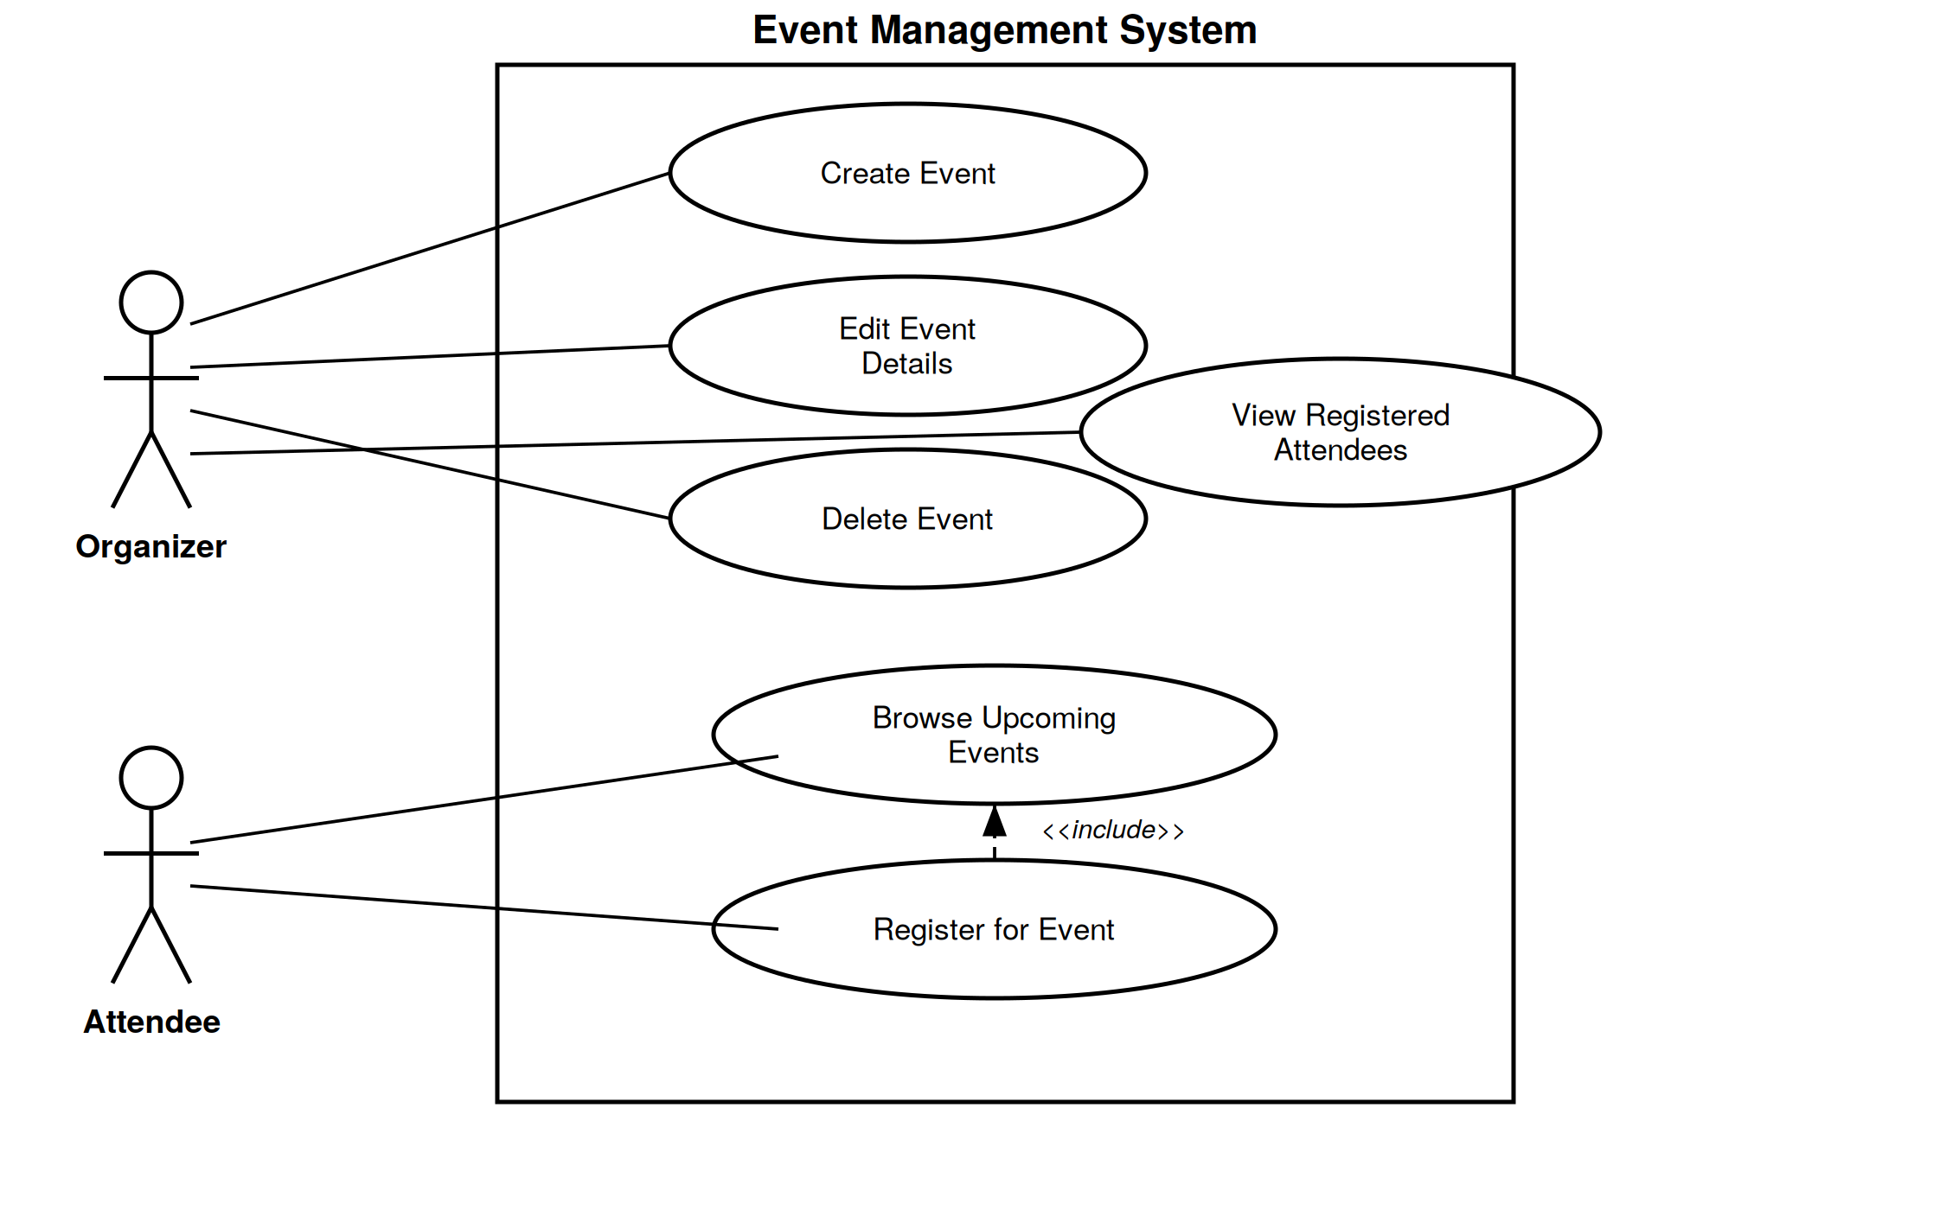
Figure 1: Use case diagram for the Event Management System

System Features
The functional requirements below are organized by system feature, since that is the most natural way to describe the event management and registration functionality of this product.

Event Creation and Management
5.1.1 Description and Priority
This feature lets an organizer create a new event, edit its details, and delete an event that is no longer needed. It is a High priority feature, since it is the starting point for every other function in the system; without it, there is nothing for attendees to register for.
5.1.2 Stimulus/Response Sequences
An organizer logs in and selects Create Event, fills in the event name, description, date, time, and location, and submits the form. The system validates the input and saves the new event, then shows it in the organizer's event list. An organizer can also open an existing event, choose Edit or Delete, and the system updates or removes the event accordingly.
5.1.3 Functional Requirements
The functional requirements for this feature are listed below.

REQ-1: The system shall allow an authenticated organizer to create a new event by entering a name (1 to 100 characters), a description (up to 1000 characters), a future date and time, and a location, and shall reject the submission with a field level error message if any required field is missing or out of range.
REQ-2: The system shall allow an organizer to edit or delete only an event that they created, and shall return an authorization error within 1 second if the organizer attempts to edit or delete an event created by someone else.

Attendee Registration
5.2.1 Description and Priority
This feature lets an attendee browse upcoming events and register for one. It is a High priority feature, since attendee registration is the main outcome the system exists to support.
5.2.2 Stimulus/Response Sequences
An attendee opens the events page, browses the list of upcoming events, and selects one to view its details. The attendee fills in the registration form with their name and email address and submits it. The system validates the form, saves the registration, and shows a confirmation message. If the attendee has already registered with the same email address, the system shows an error instead of creating a duplicate registration.
5.2.3 Functional Requirements
The functional requirements for this feature are listed below.
REQ-3: The system shall display the list of upcoming events sorted by date, showing the name, date, time, and location of each event, and shall show the full details of a selected event, including its current registration count, within 2 seconds of selection.
REQ-4: The system shall allow an attendee to register for an event by submitting a name (1 to 100 characters) and a valid email address, shall confirm a successful registration within 3 seconds, and shall reject a second registration using the same email address for the same event with a clear error message instead of creating a duplicate record.

Other Nonfunctional Requirements

Performance Requirements
The event list page should load in under 2 seconds under normal conditions, and the registration form should submit and confirm within 3 seconds, so that the system feels responsive to attendees registering for an event.

Safety Requirements
The system does not control any physical equipment and does not pose a physical safety risk to its users. The main concern is data integrity: the system shall not lose a registration or event record once the user has received a confirmation message, and the database shall be backed up at least once every 24 hours so that data can be restored in the event of a failure.

Security Requirements
Organizers must log in before they can create, edit, or delete an event, and an organizer can only manage events that they created. Attendee registration data, such as name and email address, is stored only for the purpose of managing that event and is not shared with any third party.
Security Objectives
OBJ-1: Prevent anyone other than the organizer who created an event from creating, editing, or deleting that event.
OBJ-2: Protect attendee personal data, specifically name and email address, from being visible to or usable by anyone other than the event's organizer and the system itself.
OBJ-3: Prevent an attendee's registration from being duplicated or impersonated under the same email address without detection.
Security Requirements
SEC-1: The system shall require an organizer to authenticate before any Create, Edit, or Delete action on an event is accepted, and shall reject the action with an error message if the organizer is not authenticated.
SEC-2: The system shall verify that the authenticated organizer is the owner of an event before allowing an Edit or Delete action on it, and shall return an authorization error if the organizer does not own the event.
SEC-3: The system shall not display one attendee's name or email address to another attendee, and shall only make the full list of registrants for an event visible to the organizer who owns that event.

Software Quality Attributes
Usability is the priority for the attendee facing side of the system, since attendees should be able to register for an event in a few clicks without any prior familiarity with the system. Maintainability matters on the organizer facing side, since the team will keep adding features to it over the course of the project.

Business Rules
Only the organizer who created an event can edit or delete it. An attendee can register for an event only once with the same email address, to avoid duplicate registrations.

Also include Domain requirements here.

Other Requirements
The system stores its data in a relational database with tables for organizers, events, and registrations. There are no internationalization or legal requirements for this course project beyond standard good practice around storing attendee contact information responsibly.
Appendix A: Glossary
Organizer: a registered user who creates and manages events. Attendee: a user who browses events and registers for them. REST API: Representational State Transfer Application Programming Interface, used for communication between the frontend and backend. SRS: Software Requirements Specification.

Appendix B: Field Layouts
An Excel sheet containing field layouts and properties/attributes and report requirements.

Sample sheet with information required to register the customer
Field | Length | Data Type | Description | Is Mandatory
Account Number | 16 | Numeric |  | Y
ISFC code | 11 | Alphanumeric |  | Y
Card Amount | 20 | Numeric |  | Y
Mandate Start Date | 8 | Date | Date of Mandate Registration | N
Mandate End Date | 8 | Date | Date of Mandate Expiry | N
Status | 25 | Alphanumeric | Status of Registration | Y
Customer Name | 60 | String |  | Y
Reject Reason Code | 4 | String | Reject Reason code in case mandate is rejected | N

Sample Report Requirements: Include the fields to be included in the report
Registration Report | Transaction Report
Bank Account Number | Transaction Reference Number
ISFC Code | Bank Account Number
Bank Name | IFSC Code
Account Status | Bank Name
Account Type | Customer Name
Customer Name | Card Number
Card Number | Debit Transaction Amount
SI Start Date | Transaction Date
Status | Status
Remarks | Debit Attempt Number
 | Remarks

Appendix C: Requirement Traceability Matrix
Sl. No | Requirement ID | Brief Description of Requirement | Architecture Reference | Design Reference | Code File Reference | Test Case ID | System Test Case ID
1 | REQ-1 | The system shall allow an organizer to create a new event by entering event name, description, date, time, and location. | AR-01 | DR-01 | EventController.js | TC-01
  STC-01
2 |  | The system shall allow an organizer to edit or delete only an event that they created, and shall return an authorization error within 1 second if the organizer attempts to edit or delete an event created by someone else. | AR-01 |  | EventController.js | TC-02 | STC-02
  REQ-2
  DR-02
3 |  | The system shall display the list of upcoming events sorted by date, showing the name, date, time, and location of each event, and shall show the full details of a selected event, including its current registration count, within 2 seconds of selection. | AR-02 | DR-03 | EventList.jsx | TC-03 | STC-03
  REQ-3
4 | REQ-4 | The system shall allow an attendee to register for an event using their name and email address and reject duplicate registration. | AR-03 |  | RegistrationController.js | TC-04 | STC-04
  DR-04
5 | NFR-01 | Event list shall load within 2 seconds. | AR-04 | DR-05 | EventList.jsx | TC-05 | STC-05
6 |  | Registration confirmation shall be provided within 3 seconds. | AR-05 | DR-06 | RegistrationController.js | TC-06 | STC-06
  NFR-02

